BRIDGE DETAIL FOR PAVING PROJECT
BRIDGE NUMBER

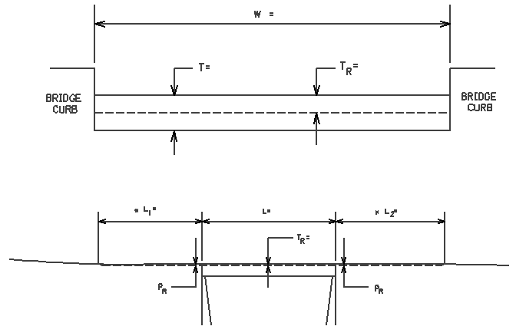

DIMENSIONS ELEVATION

W = W = bridge width curb to curb

T = _0” T = thickness of existing bituminous overlay

L₁ =
L₁ & L₂ = length of approach pavement to be removed
L₂ =

T_{R} = T_{R} = thickness to be removed and replaced on bridge

L = L = length of bridge

P_{R} = P_{R} = thickness to be removed and replaced on pavement

Notes: 1. The Engineer will determine lengths L₁ & L₂ by using a transition rate of 100 ft/inch of thickness.
2. The Department will place One Step Membrane Water Proofing System Prior to Bridge Overlay.

1-98331 bridgedetailsheetonestepdepartment
01/02/2012

